CERAMIC PARTS FOR COFFEE MACHINES
Philips Ceramics Uden has over 60 years of experience in developing and manufacturing custom made ceramic components. Our high quality products are made of high purity alumina or zirconia with outstanding properties. These materials have various advantages when used in domestic appliances such as a great resistance to wear, a high hardness and are inert. Due to the available Ceramic Injection Molding (CIM) capacity in our factory, we are able to produce our products in high quantities at competitive cost.
GRINDERS FOR COFFEE BEANS
Sharp burrs are essential for an accurate grind of beans, which is important for an even extraction of the coffee oils. Dull burrs create heat which alters the intended flavor of the espresso. Ceramic grinders are known for retaining their original sharpness longer and for their neutral taste. Experienced users even claim that ceramic disks are more quit during grinding.
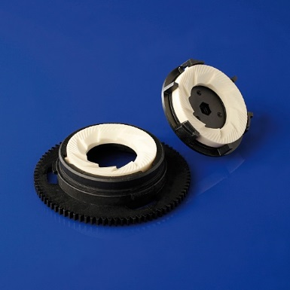
Philips grinder characteristics
- Resistant to wear
- Neutral taste
- Chemically inert
- Good heat conductivity
- Large heat capacity
- Freedom of design
- High reproducibility (geometry)
Philips ceramic grinders for beans
- Cost competitive
PIERCERS FOR COFFEE CAPSULES

Our ceramic piercing needles will pierce coffee capsules with high precision and durability. The improved design with sharper, reinforced legs will make them last for the entire lifecycle of the coffee machine. Every cup of coffee has the exact right flavor, because of the optimized flow pattern through the piercers. Neither the abrasive aluminum nor the hot water will lead to wear.
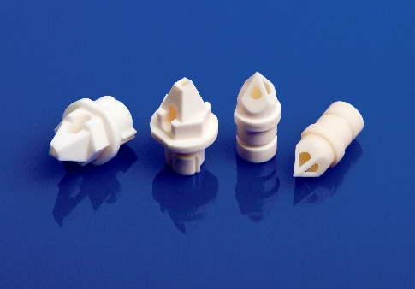
Philips piercer characteristics
- Non corrosive
- Neutral taste
- Chemically inert
- Good heat conductivity
- Sharp, reinforced edges
- Freedom of design
- High reproducibility (geometry)
Philips ceramic piercers for capsules
- Cost competitive
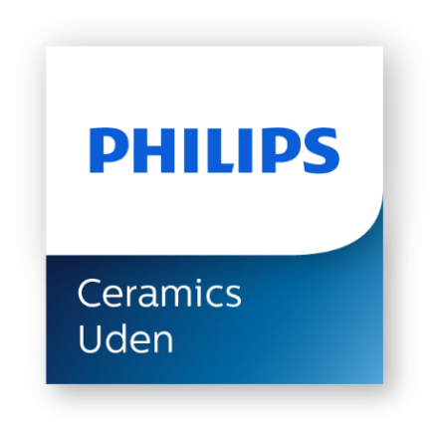

Are you interested in exploring possibilities of our custom made products by injection molding please let us know.
Philips Ceramics Uden, Frontstraat 4, 5405 AK Uden, The Netherlands
Tel: + 31 6 1138 6400, email: ceramics@philips.com
For more information: www.philips.com/ceramics

