POLYCRISTALLINE ALUMINA PROTECTION TUBES

Extrusion of alumina tubes (Al2O3) is one of our Philips Ceramics Uden’s (PCU) core technologies. PCU has been using this technology and Ceramic Injection Molding (CIM) for decades to manufacture high quality products for our translucent lighting products. The high purity of the alumina, in combination with our sintering methods, make it possible to create pore free products with a very high density. The end products have sapphire like properties for the price of regular alumina.

CHARACTERISTICS

* 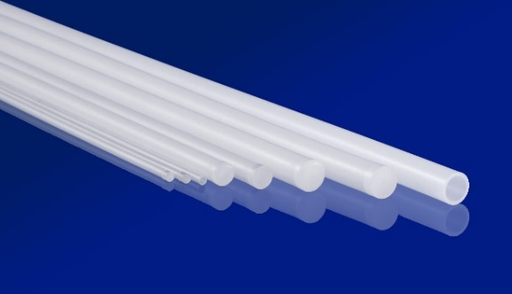High Temperature resistance (up to 1800 °C)
* High purity (>99,98+% Al2O3)
* Chemically inert and corrosion resistant
* High pressure resistance
* Outstanding electrical insulating properties
* Low creep
* High thermal conductivity
* Translucent

APPLICATIONS

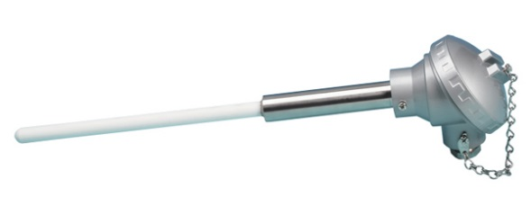Poly crystalline sapphire caps are applicable in aggressive environments and/or at high temperatures. Application areas are chemistry, oil refinery, glass industry and different laboratories, where standard ceramics or metal tubes do not meet the material stability requirements.

Our poly crystalline sapphire caps are competitive with other sapphire tubes and can substitute ceramic tubes that are not resistant against diffusion of chemicals. Therefore durability of thermocouples protected by poly crystalline sapphire tubes is much higher than in the case of standard ceramics tubes.

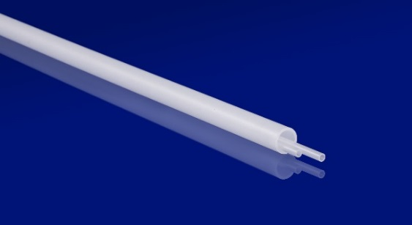Even protective tubes of small diameters are sufficiently strong and high temperature resistant. The poly crystalline sapphire caps for thermocouples are the economical choice in many applications.

A set can consist of an outer one-side sealed protective tube and one or more inner capillaries used for electrical insulation of branches of the thermocouple.

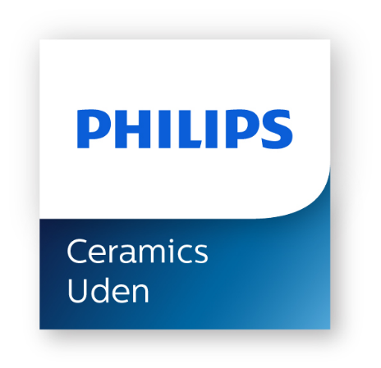

Are you interested in above mentioned products or in exploring other possibilities of custom made products by injection molding or extrusion please let us know.

Philips Ceramics Uden, Frontstraat 4, 5405 AK Uden, The Netherlands

tel:+ 31 6 1138 6400, email: [ceramics@philips.com](mailto:ceramics@philips.com)

For more information: [www.philips.com/ceramics](http://www.philips.com/ceramics)