Press Information

**Image Bank**

*(For high-resolution visuals please email* [*e.aalto@togorun.net*](mailto:e.aalto@togorun.net)*)*

**Ultrasound**

**iU22 xMATRIX**

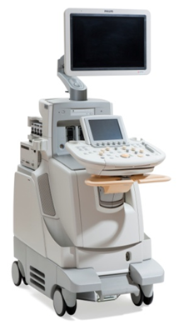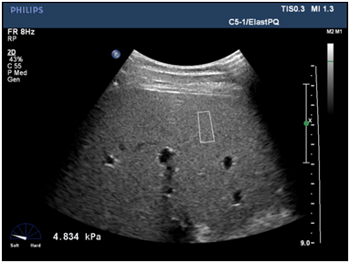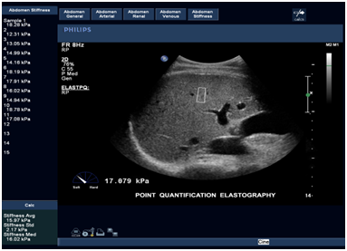

The iU22 xMATRIX allows clinicians to conduct a virtual biopsy for the diagnosis of liver fibrosis using a unique series of ultrasound pulses

This image demonstrates the sample store feature for report generation of ElastPQ results

This image shows the Shear wave ElastPQ feature with ROI sample area, kPa readout and calibrated meter display on a normal liver

**ClearVue Ultrasound System**

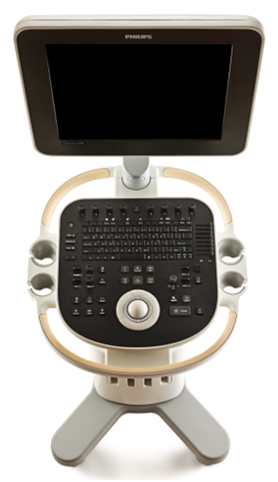

The Philips ClearVue 550 Ultrasound features innovative technology, smart design and ease of use to make high quality imaging available to a wider range of clinicians

**Digital X-ray**

***Wireless Portable Detector Sharing (Philips WPD sharing)***

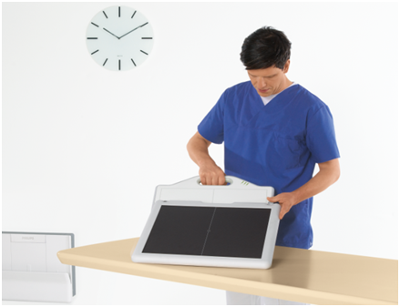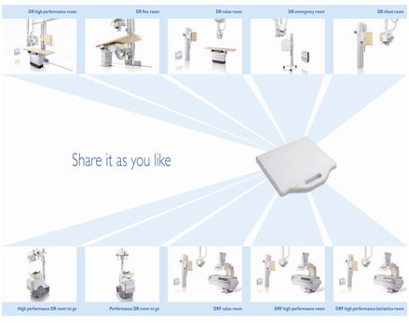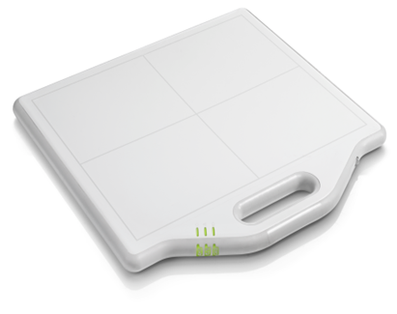

The Philips new wireless portable detector has sharing functionality for DR and DRF rooms, as well as for digital mobile systems

The Philips WPD detector can be used across systems in DR and DRF rooms

The Philips WPD sharing device is compact and portable

**Digital Diagnost**

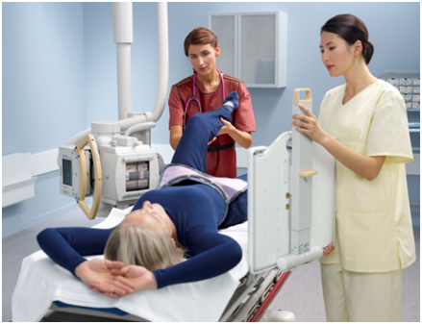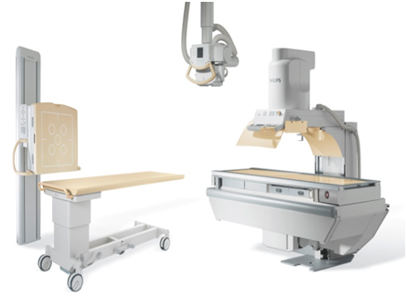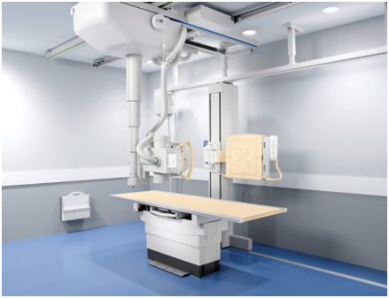

The DigitalDiagnost system is a digital radiography system designed to allow clinicians to make the most of radiography spaces and budgets

DigitalDiagnost allows smooth digital workflow and rapid results

The Philips DigitalDiagnost offers a wireless portable detector that can be moved between the table and vertical stand, and used for free exposures

**Juno DRF**

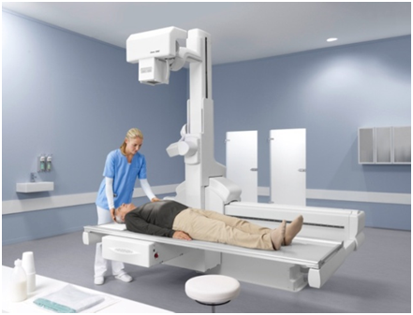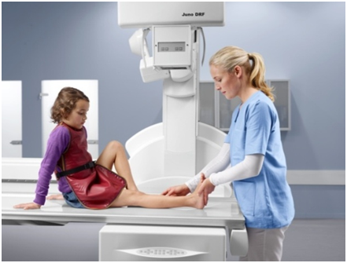

The Philips Juno DRF has a patient capacity up to 284 kg in all movements and large table top size allows for bariatric examinations

The Philips Juno DRF system is capable of a wide range of applications, including all common radiographic procedures, gastrointestinal studies, tomography and vascular studies

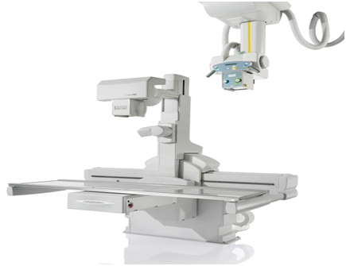

The Juno DRF system is a digital flat detector system that combines the facilities needed for digital radiography and fluoroscopy applications

**MobileDiagnost wDR**

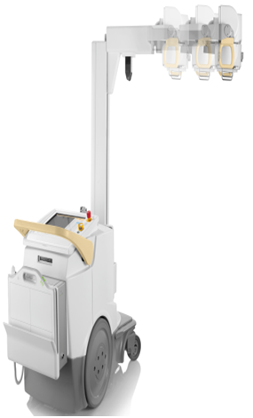

The MobileDiagnost wDR system is a fully moveable digital radiography system, able to travel throughout the care space and meet the robust challenges of a busy hospital

**Interventional X-Ray**

**Veradius mobile C-arm with Flat Detector**

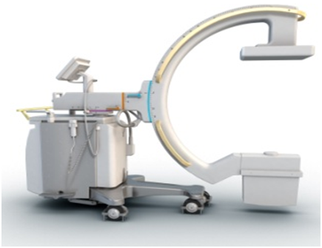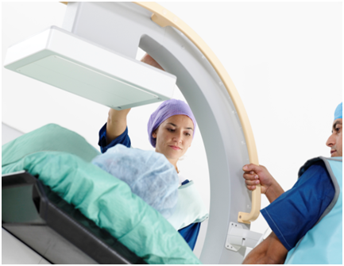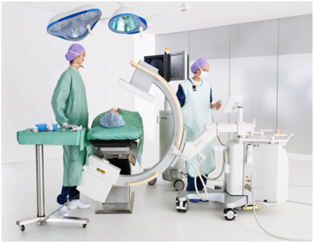

The Veradius mobile C-arm with Flat Detector system uses an innovative arch system to allow maximum flexibility to carry out surgery across patient sizes

The Veradius Neo features a completely new C-arc geometry that easily accommodates obese patients with its improved maneuverability

Flexible dose management settings and advanced flat detector imaging technology support surgeons in performing the latest image-guided surgical interventions

**Women’s Healthcare**

**MicroDose Mammography**

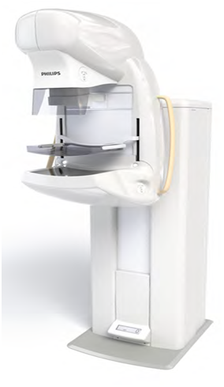

The MicroDose Mammography system provides quicker mammography scans and utilizes X-ray photon-counting technology to reduce radiation dose without reducing image quality

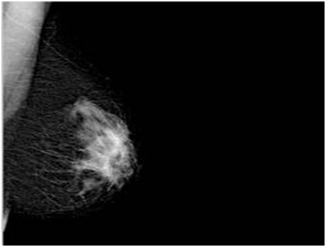

LMLO (Left mediolateral oblique) projection of a breast with cancer

**MammoDiagnost DR with Advanced Stereo**

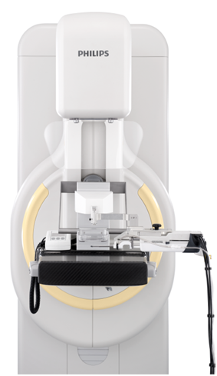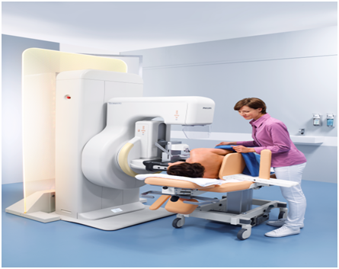

The Philips MammoDiagnost DR with Advanced Stereo option carries out mammographically-guided stereotatic biopsies to guide radiologists to the investigation sites

The Philips MammoDiagnost DR with Advanced Stereo provides a more comfortable, relaxed and faster mammogram experience with low radiation exposure

**Achieva MRI with Elite Breast Clinical Solution**

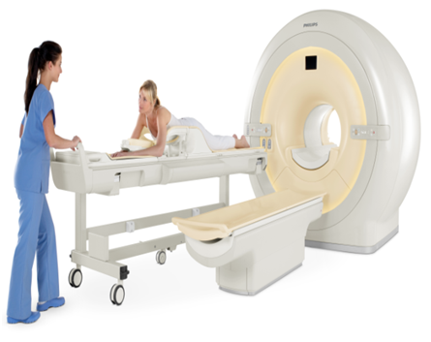

Achieva MRI with Philips Elite Breast uses sophisticated image-based shimming techniques to detect the relevant breast and thorax wall volume and optimize magnet and RF shimming for each individual patient accordingly

**Computed Tomography**

**iDose4**

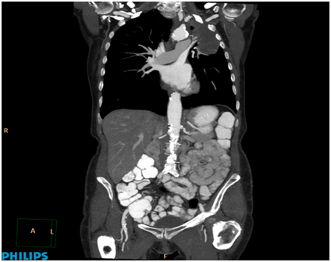

Chest, abdomen and pelvis scanned at 80 kVp and iDose4 Level 3

**Clinical informatics**

**IntelliSpace Breast solution**

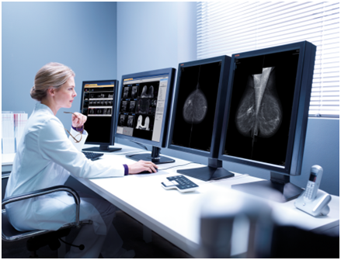

The Philips IntelliSpace Breast solution is designed to simplify workflow by serving up a patients’ mammography, ultrasound and MRI images at a single workspace

**IntelliSpace PACS 4.4**

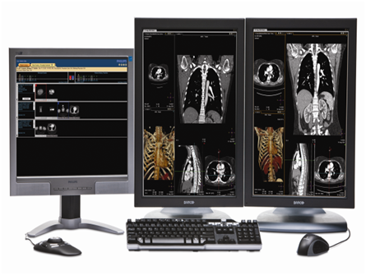

Philips IntelliSpace PACS Radiology 4.4 supports workflow efficiency with a customizable, intuitive user interface and advanced workflow tools that reduce the steps required to view and interpret studies

**Nuclear Medicine**

**TruFlight Select PET/CT**

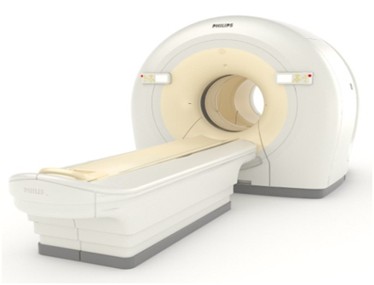

The TruFlight Select PET/CT system brings TOF technology to the PET/CT system, which is designed to enhance image quality by reducing image artifacts and providing higher sensitivity

**Ingenuity TF PET/CT**

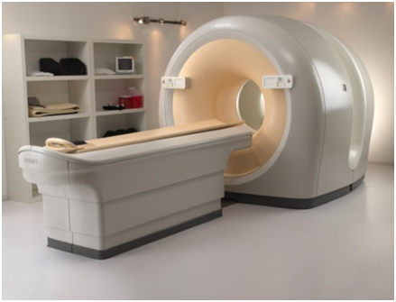

The Ingenuity TF PET/CT pairs TOF technology with PET and CT scans to give radiologists a full range of possibilities for patient dosage based on patient needs

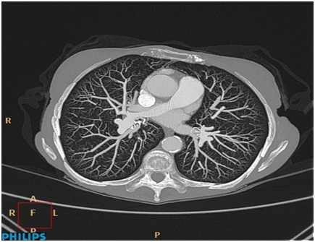

Ingenuity CT with iDose4 demonstrating outstanding contrast resolution and visualization of small vascular structures out to the peripheral lung. Image acquired in 6 seconds and reconstructed in 39 seconds. Other scan parameters: 80 kVp, 0.9 mSv, 138 mAs,32 cm scan length

**Magnetic Resonance Imaging**

**Ingenia 1.5T and 3.0T systems**

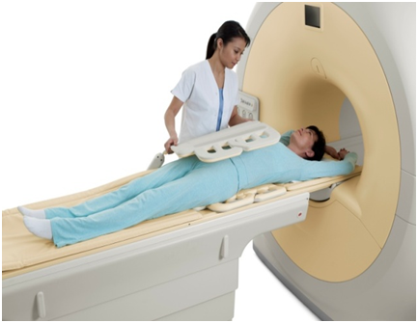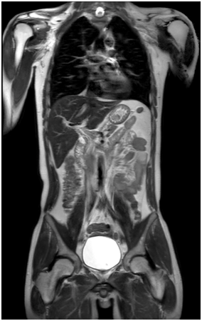

The Ingenia systems elevate clinical performance for traditional and growth applications through up to 40 percent increase in signal-to-noise ratio (SNR) and the largest homogenous field-of-view for a 70 cm bore

Complete torso imaging scan

**Sonalleve MR-HIFU**

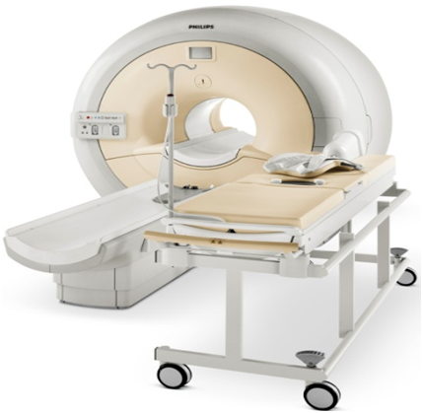

The Sonalleve MR-HIFU (High Intensity Focused Ultrasound) system offers a non-invasive alternative to traditional surgical treatments for uterine fibroids in women, by combining magnetic resonance (MR) imaging with high-intensity focused ultrasound (HIFU) therapy

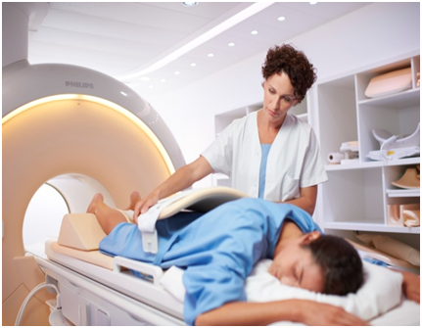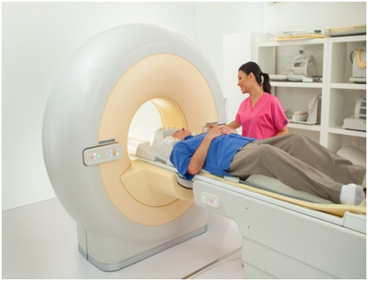

Philips has developed Sonalleve MR-HIFU solutions for the treatment of uterine fibroids and bone metastasis pain palliation, and is investigating further application areas. *(The Philips Sonalleve MR-HIFU system or some of its applications are not for sale in some countries. To determine availability in your area, please contact your local Philips representative).*

High Intensity Focused Ultrasound (HIFU) is used to heat and coagulate tissue deep inside the body, MRI measures temperature change in the body

**Ambient Experience**

**Ambient Experience**

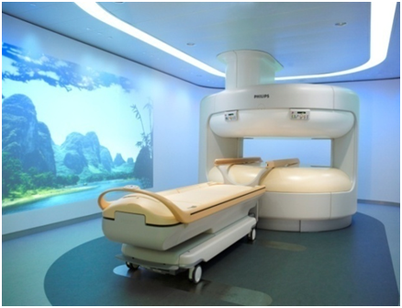

Philips Ambient Experience provides a positive environment for patients and health care professionals to enhance clinical processes and patient care

**Speech Processing**

**SpeechMike**

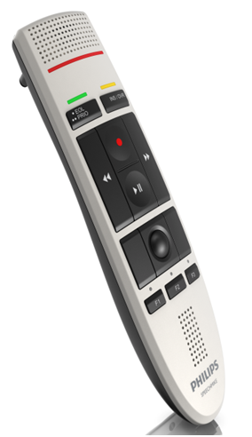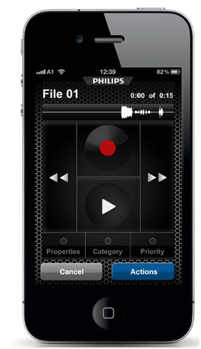

The Philips SpeechMike is the first and only dictation microphone on the market featuring an antimicrobial surface, drastically improving hygiene in clinical environments.

The Philips SpeechExec dictation workflow solution, is designed to facilitate the recording, editing and sending of dictation files from an iPhone