HIGH TEMPERATURE RESISTANT OVEN FURNITURE

Philips Ceramics Uden develops custom made oven furniture. The high purity alumina that is developed for translucent lighting products, has various advantages when used in carrier materials for high temperatures. These carriers are made of ultra-pure (99,99%) Poly Crystalline Alumina (PCA) which has outstanding properties like f.e. very little creep compared to other alumina’s.
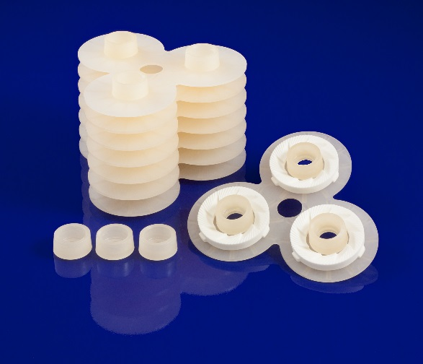
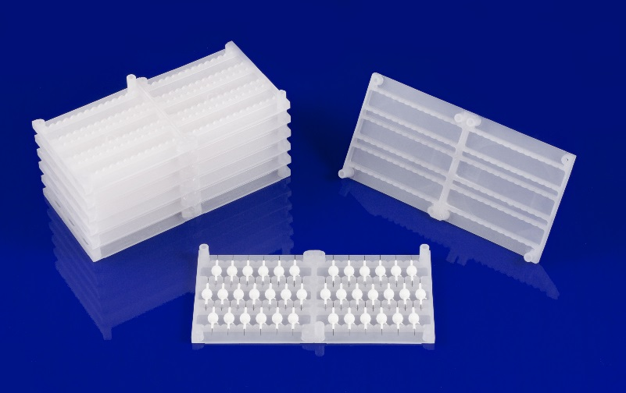

CHARACTERISTICS
- Temperature resistance (and therefore no creep) up to 1800°C.
- Freedom of design opens possibility of achieving an unprecedented product to carrier weight ratio in a furnace. This results in a higher loading efficiency and reduction of CO₂ emission.
- In contrast to regular alumina, PCA is transparent for infrared radiation. The heat transport from the heating elements to the products that are sintered is greatly improved, resulting in improved temperature homogeneity.
- High purity material, no contamination of the sintered products by the carrier.
- Pore free material, so highly reduced absorbance of foreign material in the carrier, reduced sticking and smooth surface.
- Carrier can be used in all gas atmospheres in the furnace.
- Due to the reduced weight the carrier is easier to handle by operators.
- High reproducible geometry by injection molding of the carrier.

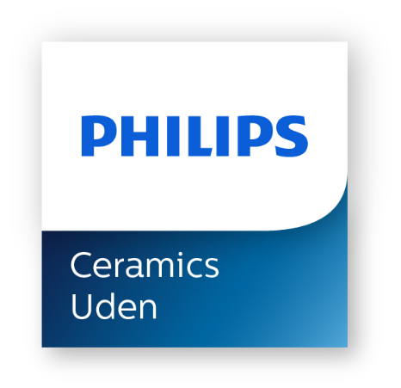

Are you interested in exploring possibilities of our custom made products by injection molding please let us know.
Philips Ceramics Uden, Frontstraat 4, 5405 AK Uden, The Netherlands
tel:+ 31 6 1138 6400, email: ceramics@philips.com

For more information: www.philips.com/ceramics

