3GPP TSG-SA3 Meeting #104-e S3-211XYZ

e-meeting, 16 – 27 August 2021

Source: Philips International B.V.

Title: Update Solution 11 for reduced key update overhead

Document for: Approval
Agenda Item: 5.11

1 Decision/action requested
Acceptance of conclusions in Solution #9 of TR33.850.

2 Detailed proposal
*** BEGIN OF 1st CHANGE ***

6.11 Solution #11: Update the keys used to protect the MBS traffic

6.11.1 Introduction
This solution addresses Key issue #3 to update the keys to protect the MBS traffic. The MBS traffic is protected between MBSF-U and UEs. The basic idea is to use the signalling messages for the key update procedure. The UEs, which belong to a multicast group, acquire the same group keys as in the MBSF-U. The security protection is enabled in service layer.

6.11.2 Solution details

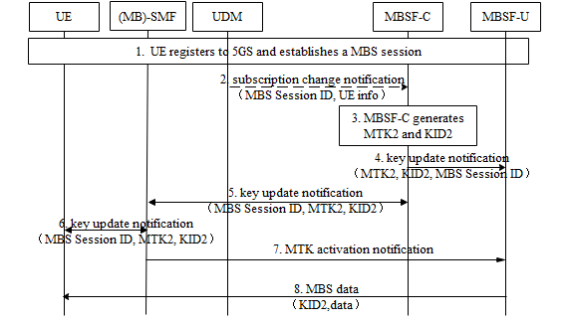
Figure 6.11.2 -1: Procedure for MTK update
1. The UE registers to 5GS and establishes a MBS session, during which MBSF-C generates MTK1&KID1 and distributes them to MBSF-U and UEs. MTK1&KID1 are used to protect the MBS traffic. Details can be found in solution 3 or solution 8.
2. MBSF-C subscribes to the UDM/UDR on the changes of the multicast information including the authorization information. The UDM/UDR notifies the MBSF-C when the authorization for a UE to join the multicast service/application is revoked. The MBS Session ID and UE info (i.e. GPSIs, number of UEs) are included in the notification. The MBS Session ID may be a Temporary Mobile Group Identifier (TMGI) or a multicast address. UE info indicates the change of authorization info.
3. MBSF-C triggers the MTK update based on the changes of authorization info or the key lifetime of MTK1. MBSF-C generates MTK2 and KID2 for this MBS session. For example, if the number of UEs whose authorization is revoked reached the threshold, the MBSF-C triggers the MTK update. It’s operator’s choice to decide the policy for different event.
4-5. MBSF-C distributes MTK2, KID2 and MBS Session ID to (MB)-SMF and MBSF-U respectively.
6. (MB)-SMF distributes MTK2, KID2 and MBS Session ID to the authorized UEs in the connected state whose MBS sessions are not released. Confirmation for update notification is responded to (MB)-SMF. With the confirmation info, (MB)-SMF determines to activate MTK2 based on local policy. For UEs in idle or inactive state UEs, the updated key are delivered when UE joins or actives the MBS session.

7. If the procedure to update the key in UE side is finished, (MB)-SMF indicates MBSF-U to activate the MTK2 for the corresponding MBS session.
8. MBSF-U uses MTK2 and KID2 to protect the MBS traffic.
The above text describes the security handling when SMF and MB-SMF are co-located. If SMF and MB-SMF are deployed separately, MBSF-C distributes MTK2, KID2 and MBS Session ID to MB-SMF. Afterwards, MB-SMF distributes MTK2, KID2 and MBS Session ID to the authorized UEs via SMF. MB-SMF indicates MBSF-U to activate the MTK2

6.11.2.1 Optimized signalling approach
The communication overhead of the key update mechanism in terms of point to point messages – Step 6 in Figure 6.11.2 -1 – can be reduced from N messages to ~ SQRT(N) messages, where N is the number of UEs in connected state that joined the MBS session, by applying the communication optimized approach in Solution #9.
To this end, the following changes are required:
- In Step 1, the MBSF-C has to generate M different Transport Keys (TKs) and distribute them to MBSF-U and UEs. As in the communication optimized approach in Solution #9: (1) each UE has a MUK, a TK, and a MTK; (2) the MUK is used to securely distribute the TK and the TK is used to securely distribute the MTK; and (3) disjoint sets of L UEs receive the same TK so that M•L ≥ N, where N is the total number of devices.
- In Step 3, the MBSF-C has to generate a new TK for the L-1 UEs in the same set of a UE whose authorization info has changed.
- In Step 4, KID2’ includes the identifier of the new MTK, MTK2, and also the MGKM message defined in Solution #9 and used to protect the new MTK with the M current TKs.
KID2’ := KID2|MGKM
Note 1: MGKM is generated by the MBSF-C and combined with KID2 into KID2’ to avoid the integration of any security functionalities into the MBSF-U.
- In Step 5, the MBSF-C distributes the new TK to the (MB-)SMF.
- In Step 6, ONLY the L-1 UEs that shared the same TK as the UE whose authorization info has changed are updated by means of a point to point connection. This means that only L-1 unicast interactions are required, instead of N. These unicast messages are protected with the MUK.
- In Step 8, the MBSF-U uses MTK2 to protect the MBS traffic. The MBSF-U appends KID2’ to the message. A UE uses: (1) KID2 in KID2’ to determine the usage of a new MTK and (2) if the UE did not receive MTK2 in Step 6, the UE uses MGKM in KID2’ to access the new MTK2 by using its TK to decrypt/verify MTK2.

6.11. 3 Evaluation
This solution addresses Key issue #2 to update the key for protecting the MBS session. The solution protects the MBS traffic between MBSF-U and UEs.
MBSF-C decides to trigger the MTK update procedure based on the changes of authorization info or the key lifetime of MTK. The new MTK and KID are sent to UE and MBSF-U respectively.The key update procedure by SMF to the UEs incurs signalling overhead proportional to the number of UEs in connected state that joined the MBS session. This overhead is proportional to the square root of the number of UEs in the MBS session if the optimized signalling approach in 6.11.2.1 is applied. NAS SM messages need to be delivered to those UEs when a key change happens.
This doesn’t require idle or inactive state UEs to transition to the connected state to receive the key update.
Editor’s Note: Further evaluation is FFS.

*** END OF 1st CHANGE ***

