

# Technology Backgrounder

**Women’s Healthcare**

Early screening and timely diagnosis are key to recovery and survival for women with breast cancer. With a range of innovative breast imaging technologies, Philips is setting new standards in breast care. Our portfolio is designed to take on the challenges of the future, offering low-dose mammography, ultrasound and MRI, all supported by leading-edge information management. These solutions allow the user to pick up lesions early, diagnose them quickly, enhance efficiency and productivity, and give patients physical comfort.

***MicroDose Mammography***

For more than forty years, mammography has been the most common screening tool used for the early detection of breast cancer. At ECR 2012, Philips is showcasing the next generation of digital mammography— MicroDose Mammography. Importantly, Philips MicroDose uses a substantially lower average X-ray dose than other full-field digital mammography (FFDM) systems, thanks to its unique photon-counting detector technology. This is a direct way to capture each and every X-ray photon without any conversion steps, additional noise, or the need for an anti-scatter grid as with other FFDM systems. Photon counting improves dose efficiency making it possible to reduce the radiation dose by up to 50% – while the superb image quality enables excellent cancer detection. MicroDose Mammography images deliver 25 megapixels of resolution, enabling visualization of fine, detailed structures in the breast such as microcalcifications and spiculations. Plus, as many as 15 four-image examinations per hour can be performed to speed throughput and gain a competitive advantage. MicroDose Mammography offers an innovative new approach to breast cancer screening.

During ECR, Philips is also sponsoring a symposium, entitled **Shaping the Future of Breast Cancer Screening**. Being held on Saturday 3 March, between 12:30 and 13:30, at Room N/O, Level 01, the symposium will see the presentation of the latest results from two different studies involving single-shot spectral mammography, one covering breast density measurements and the other lesion characterization. In addition, a summary of a study conducted in the U.S. assessing the performance of Philips MicroDose in comparison with another FFDM system, will be highlighted, alongside a discussion regarding the benefits and possibilities of reducing radiation dose while still maintaining image quality within mammography screening.

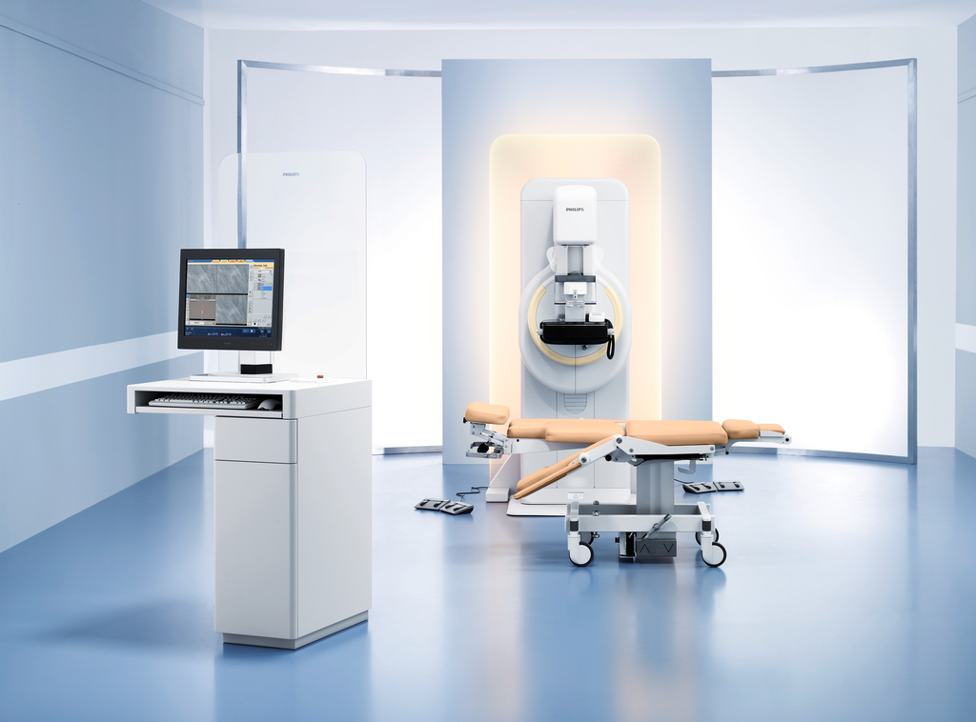***MammoDiagnost DR with Advanced Stereo option***

Philips’ direct digital mammography solution offers superb visualization for the clinician and less invasive treatments for patients. With MammoDiagnost DR with Advanced Stereo option, radiologists can carry out mammographically-guided stereotactic biopsies with automated processes and an innovative optical target planning tool. In fact, the target planning tool offers a feature allowing for corrections to reach a set biopsy target without moving the patient or taking a new image: even if a selected biopsy lesion is located too close to either the paddle or detector. This feature not only saves time, but also provides comfort for the patient, and may reduce the need for retakes which can lead to additional X-ray dose. Features include:

* Excellent image quality and contrast resolution with UNIQUE image processing
* Award winning ergonomics and intuitive UI based on the Eleva concept
* Patient comfort and fast exam time
* Complete Mammography portfolio – DR, CR, viewing workstation and CAD

***iU22 xMATRIX Ultrasound***

Philips’ premium iU22 breast ultrasound system combines a number of clinically proven technologies to deliver crisp, high-definition images designed to help clearly distinguish between normal and abnormal tissue for improved diagnosis. Tissue aberration correction compensates for speed-of-sound variations to produce clear, detailed images even in women with dense or fatty breast tissue. Volume imaging with the VL 13-5 transducer provides clinicians with revealing information, including visualization of the C-plane. End-users can view target areas from any plane to better characterize the extent of breast masses. Elastography enables providers to differentiate relative stiffness of tissue through sonographic examination using Philips L12-5 transducer and Advanced Breast Tissue Specific Imaging (TSI) preset.

***Ingenia 3.0T MRI***

Powered by the breakthrough dStream architecture, the Ingenia 3.0T is the first MR system that brings MR signal digitization to where it has never been before – in the RF coil, as close to the patient as possible.

The dStream unleashes the power of digitization by delivering a high purity MR signal for increased SNR, combined with excellent workflow and ease of use for greater efficiency in your daily operations.

Philips Ingenia brings consistent image quality for all applications pairs with clinical versatility to expand into new areas such as body/oncology, in a wide aperture system for exceptional patient comfort. In addition, productivity is enhanced with every feature of the Ingenia, with automation where it makes sense, while still giving you the control you want or need.

***Achieva MRI with Elite Breast Clinical Solution***

Clinical studies suggest that MRI may be helpful in breast care, particularly in imaging high-risk patients. As a leading provider of MRI solutions for women’s healthcare, Philips developed the Achieva MRI with Philips Elite Breast as a complete clinical solution based on insights into the needs of clinicians and patients. It was designed from the ground up to make breast MRI easier.

* MammoTrak dockable trolley support system includes breast coils that provide superb visualization of small lesions
* SmartExam Breast delivers excellent, reproducible image quality – even in cases of silicone implants or surgery
* DynaCAD Enterprise computer-aided imaging system lets the clinician access morphologic data and kinetic information to increase diagnostic confidence

***IntelliSpace Breast solution***

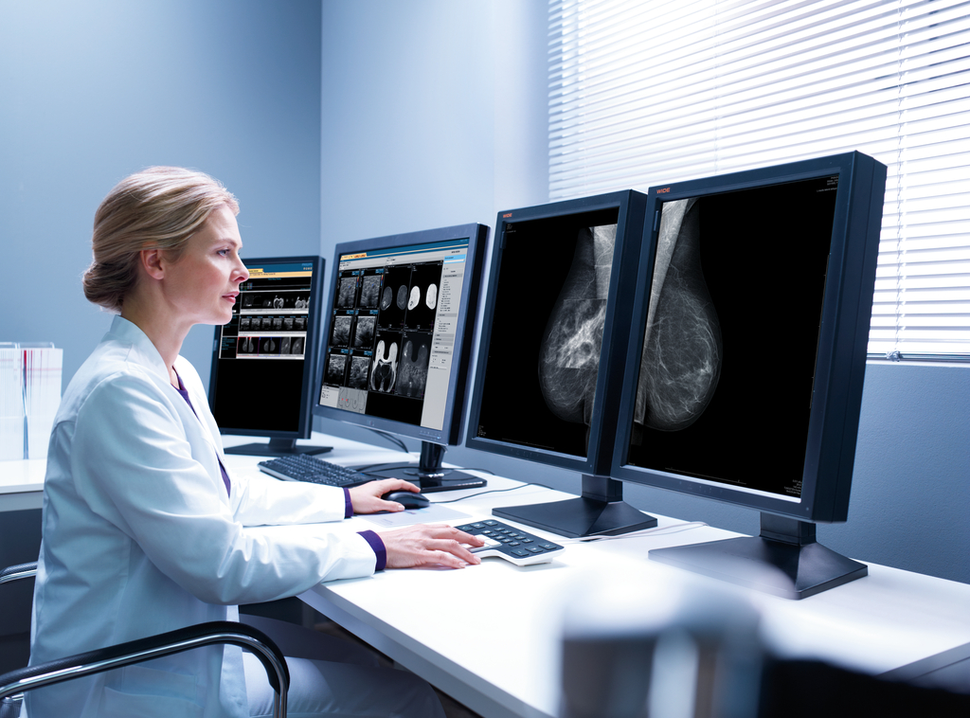The Philips IntelliSpace Breast solution is designed to simplify workflow by serving up a patients’ mammography, ultrasound and MRI images at a single workspace – so that the user no longer needs to run between workstations or reading rooms. IntelliSpace Breast solution allows the user to:

* Save space in the reading room by viewing all studies from multiple modalities and multiple vendors on a single workstation
* Save time in reviewing patient history by having prior mammography, US and MRI images automatically opened in an intuitive arrangement
* Improve quality of care - report consistently in compliance to standards thanks to integrated BI-RADS reporting

**For further information, please contact:**

Sabine van Deursen

Communications Manager Philips Healthcare

Tel: +31 (0)6 1504 3894

Email: [sabine.van.deursen@philips.com](mailto:sabine.van.deursen@philips.com)

**About Royal Philips Electronics**

Royal Philips Electronics of the Netherlands (NYSE: PHG, AEX: PHI) is a diversified health and well-being company, focused on improving people’s lives through timely innovations. As a world leader in healthcare, lifestyle and lighting, Philips integrates technologies and design into people-centric solutions, based on fundamental customer insights and the brand promise of “sense and simplicity.” Headquartered in the Netherlands, Philips employs approximately 122,000 employees with sales and services in more than 100 countries worldwide. With sales of EUR 22.6 billion in 2011, the company is a market leader in cardiac care, acute care and home healthcare, energy efficient lighting solutions and new lighting applications, as well as lifestyle products for personal well-being and pleasure with strong leadership positions in male shaving and grooming, portable entertainment and oral healthcare. News from Philips is located at [www.philips.com/newscenter](http://www.philips.com/newscenter).